**Nagios False & Host Down Alert SOP**

**Agenda**:

This document for False and Host Down alert purpose

Step 1: Please login to the respected server.

Step 2: Please go the Nagios path as mentioned below

**Path: C:\Program Files\Nagios\NRDS_Win\logs**

Step 3: Now you can see the current Plugin output log in mentioned location.

Step 4: In current log you can find the plugin return code. Based on the return code we need to troubleshoot

**Return Code**

Nagios determines the status of a host or service by evaluating the return code from plugins. The following tables shows a list of valid return codes, along with their corresponding service or host states.

|  |  |  |
| --- | --- | --- |
| **Plugin Return Code** | **Service State** | **Host State** |
| 0 | OK | UP |
| 1 | WARNING | UP or DOWN/UNREACHABLE* |
| 2 | CRITICAL | DOWN/UNREACHABLE |
| “Blank” | False Alert | False Alert |

**Plugin Output Example**

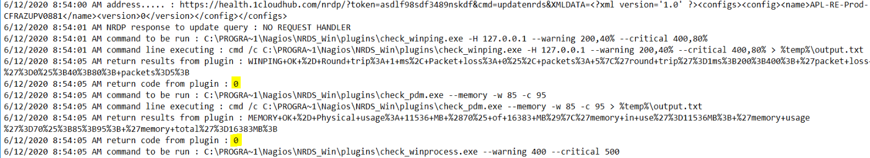

If received the False / Host down alert, please follow the steps

Please choose Task scheduler

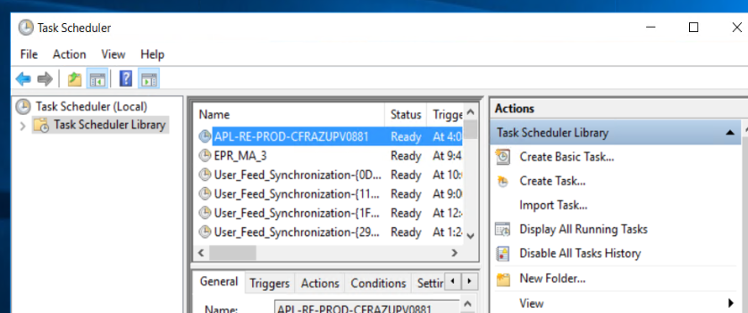

Step 1:

Please disable the Nagios task as refer by above snip

Step 2

Please delete the current debug logs and enable the task then choose Run

Note: If above mentioned steps didn’t help, please reach Next level Me or Santhosh